Introduction:
Healthy Veggies is a service that provides fresh organic and hydroponic vegetables from community and rooftop farms delivered daily to your home at a reasonable price. All organic and hydroponics vegetables are harvested from the farms only when they are ordered to ensure that our customers in the San Francisco area get real fresh vegetables in every order. Although many supermarkets like Whole Foods and Safeway or retail stores with food sections like Target and Rainbow, which sell nonchemical or less chemical vegetables that are ready to eat, most are packed and left on display shelves for days. Thus that is not really fresh if compared to the Health Veggies service. All vegetables that Healthy Veggies deliver to the consumers come from the community and rooftop farms that are grown by organic or hydroponic approved methods. In recent years people are more and more concerned about their health and the safety of food they consume. Research has found that the percentage of Americans who frequently eat fresh fruit and vegetables have increased from 55.7% in January to 57.4% in February and March and were higher than in the same months in 2011. (http://www.coreperformance.com) About 57 percent in 2011 say they were concerned or very concerned about the safety of food (http://www.npr.org) and a full two-thirds of U.S. voters are willing to pay more for safer food, according to a recent survey commissioned by the Pew Charitable Trusts. (http://www.huffingtonpost.com)
Healthy Veggies will bring good quality and healthy vegetables from community and rooftop farms to your door daily and will also improve the local economies in our communities. With the service of Healthy Veggies, not only our customers are getting healthy from our fresh organic and hydroponics vegetables, but the communities are also getting improvements in environment, economic, and social standings. Moreover, Healthy Veggies are delivered only by bicycles to avoid traffic congestion to ensure that our consumers receive the orders on time and also to reduce pollution.

Mission Statement:
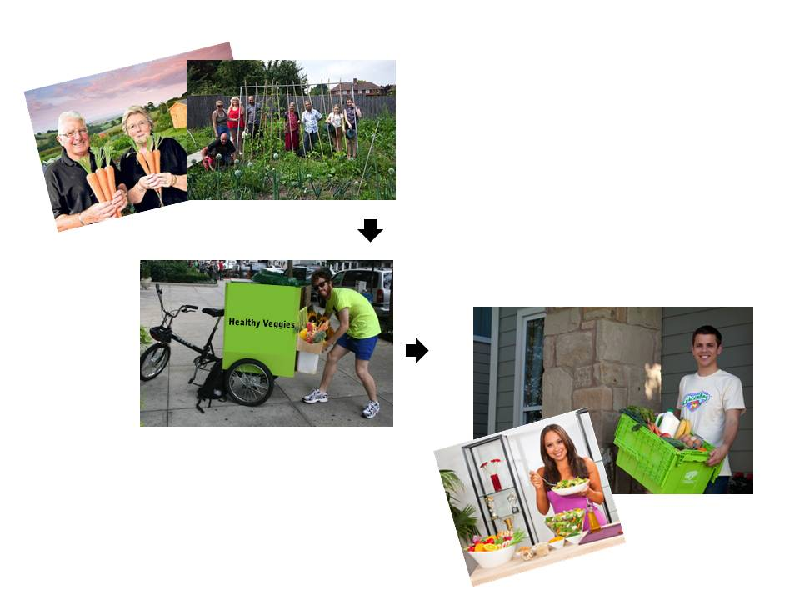
Healthy Veggies is a service that promotes good health to people and environmental awareness to the communities through real fresh organic and hydroponics vegetables at a reasonable price. We are proud to be a service that help Americans improve their health and communities.

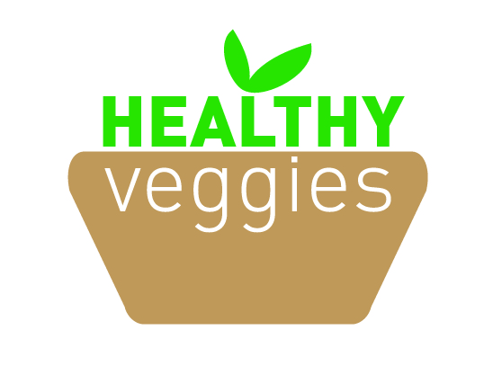
Logo:

